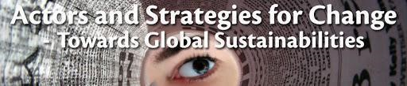

Course books for Actors and Strategies for Change: Towards Global Sustainabilities 2023
Welcome to the Spring 2023 Actors and Strategies for Change course, below you will find information related to the course books.
All students will select one book from a list of the following 8 books about actors, strategies, and change. Read reviews of the books to inform your choice and think about how you could use your book in the course.

1. Title: From what is to what if: unleashing the power of imagination to create the future we want (2019)
(eBook available through university library)
Author: Rob Hopkins
2. Title: Emergent Strategies (2017)
(eBook available through university library/ Reference copy available at CEMUS library)

Author: Adrienne Maree Brown

3. Title: How to Change the World: Social Entrepreneurs and the Power of New Ideas
(2007)
(eBook available through university library/ Reference copy available at CEMUS library)

Author: David Bornstein

4. Title: RE: Mindings, Co-constituting Indigenous/Academic/Artistic Knowledges (2014)
(eBook available through university library)
Authors: Johan Gärdebo, May-Britt Öhman and Hiroshi Maruyama

5. Title: New Perspectives on Environmental Justice: Gender, Sexuality, and Activism (2004)
(eBook available through university library) Author: Rachel Stein

6. Title: Our Word is our Weapon (2004)

(Reference copy available at CEMUS library)

Author: Subcomandante Marcos

7. Title: Liberation Ecologies (2004)

(eBook available through university library)

Authors: Richard Peet and Micheal Watts

8. Title: Waging Nonviolent Struggle: 20th Century Practice and 21st Century Potential (2005)

(eBook available through university library/ Reference copy available at CEMUS library)

Author: Gene Sharp

